So we are working on sih
Alright we have selected our problem statement , finalized our produt and made a proper ppt .
I want you to be our front end developer
I will give you my website inspiration , all the dashboard inspiration .
you should first understand our idea completely , understand how our product should look like .
then you wil give me a prd , techstack , and design document which I can use and start vibe coding .
https://cosmoq.framer.website/ this is the home page insipiration
go through this , I want all the elements in this website as our home page .
just it will be customized for our product .
just remove payment plans
everything else is fab
now after this page we will have a direct home dashboard
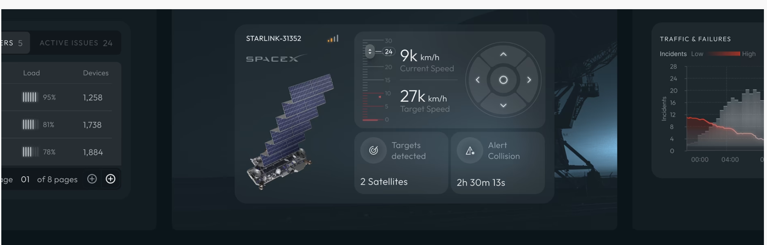
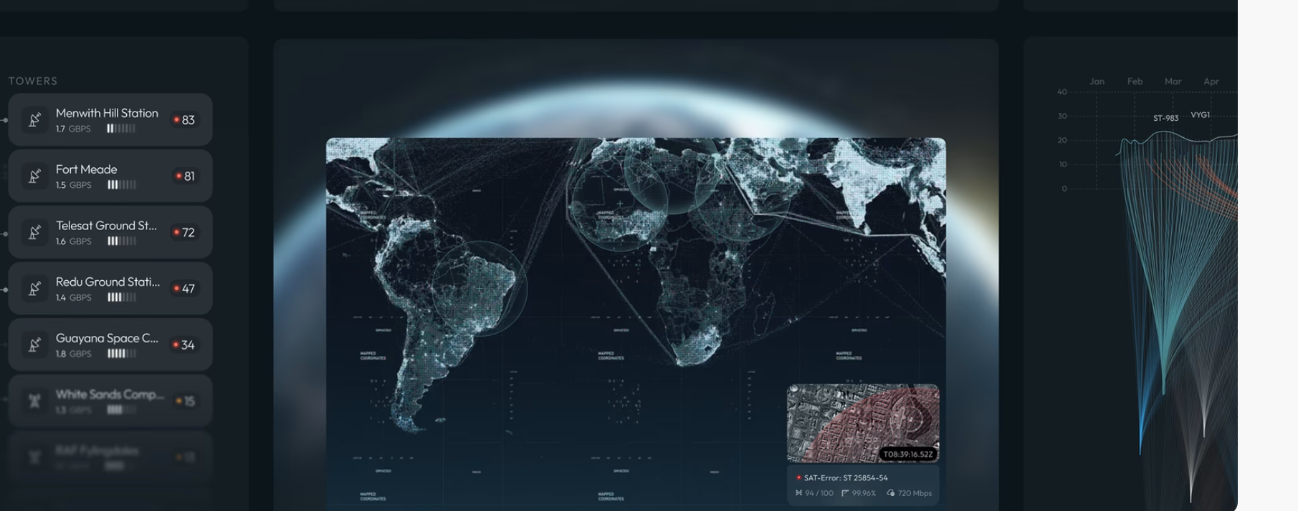
this is our inspiration for our infographics , user interface and everything else .
for the theme and colour pallete we will use
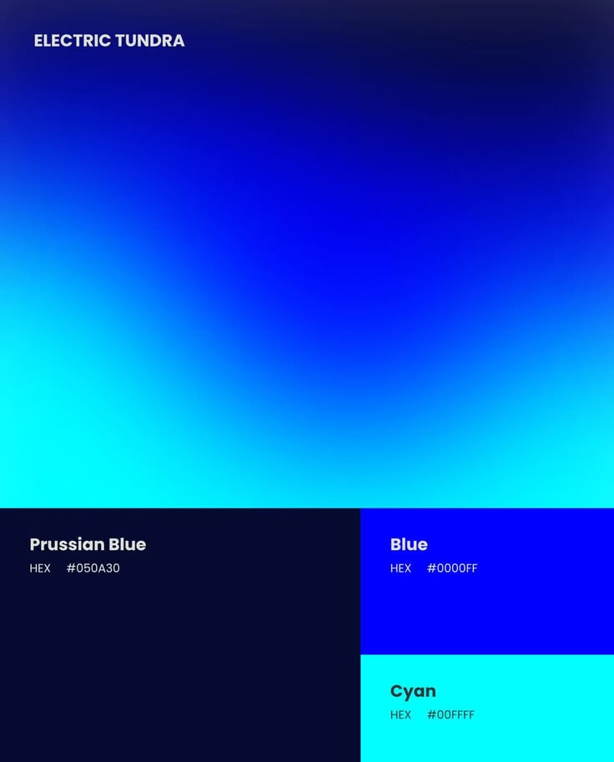
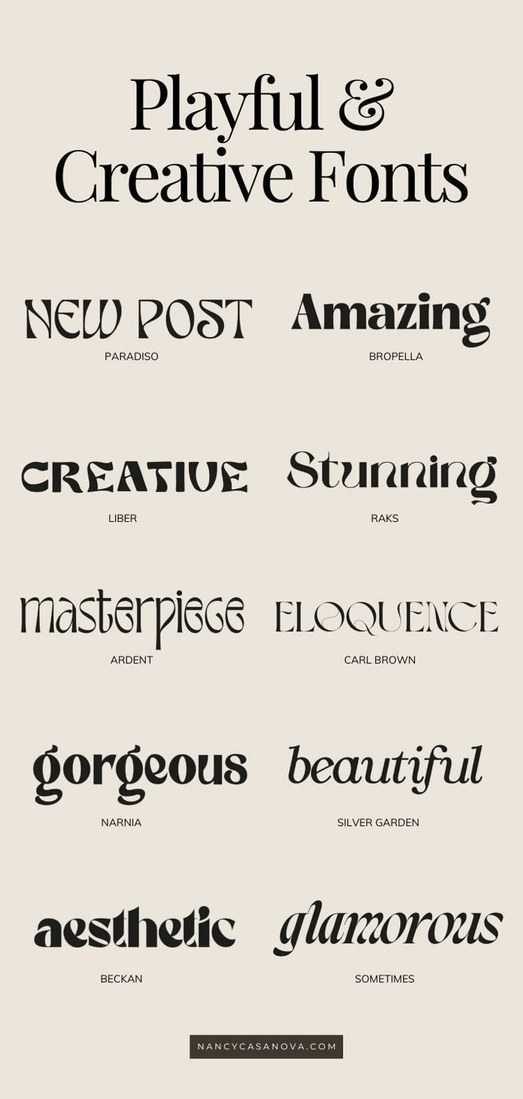
use this as font wherever necessary like for all information and everything else

this font will be for our main name

this will be our logo
, if you need anything else , just ask me to send it .
but give me a excellent prd and other relevant documents

